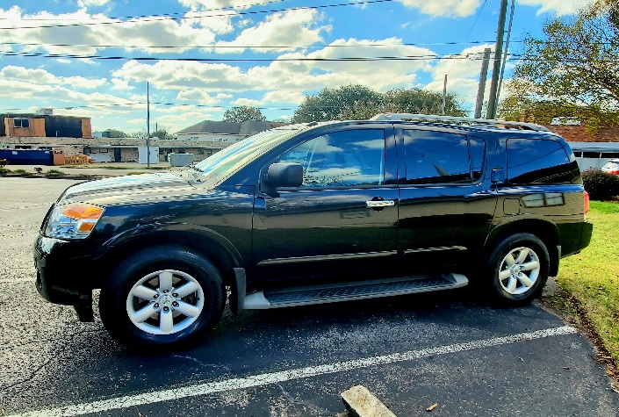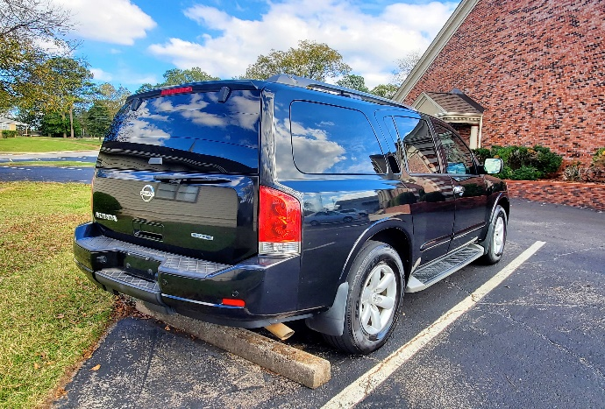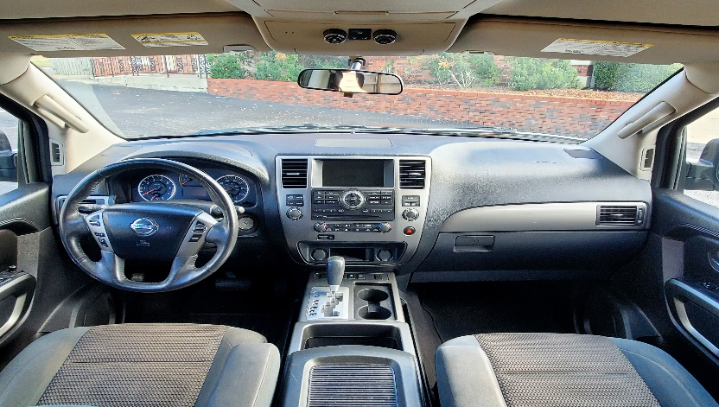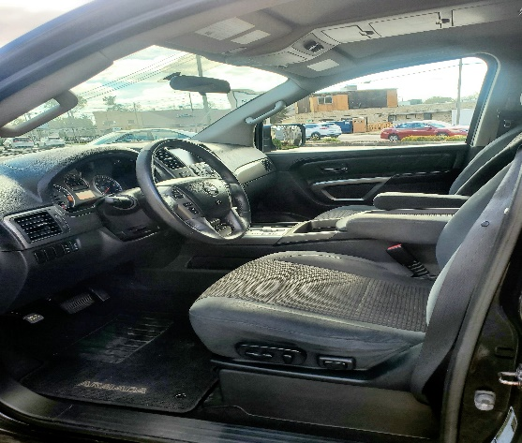

**For Sealed Bids thru November 22nd 2024**

2015 Nissan Armada

V-8, Automatic, 3rd Row Seating

148k Miles

*Sold As-is

NADA Retail $8,100

Name: _______________________________

Phone Number: ___________________

Bid Amount: ________________

For more info call (*256) 534-2423*

*\*North Alabama Educators Credit Union*

*reserves the right to refuse any bid.*